ECS Music News 2025 and Music Opportunities 2026
Faith News Our Senior School Production in Term 1 this year was a spectacular show involving around 150 of our students from year 3 – year 10. Both performances showcased exceptional acting, dancing, and singing from the principal cast, while the choir and orchestra demonstrated remarkable proficiency. The school orchestra undertook the considerable challenge of accompanying a musical with only one term of preparation, and their commitment and skill were clearly reflected in the quality of this performance.
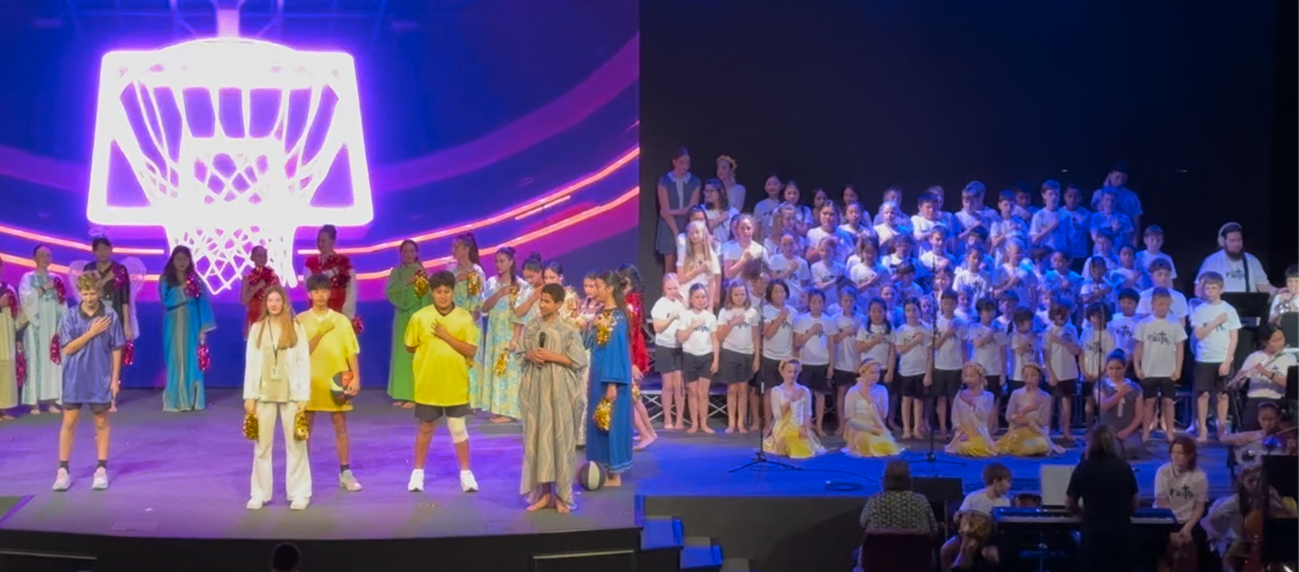

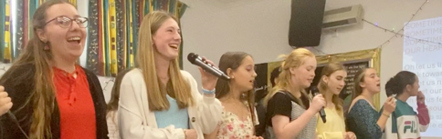
Easter Service Every year at the end of Term 1 our school comes together for a beautiful Easter Service. This year our Senior Acapella group (a first for ECS) presented the beautiful ‘Sometimes Alleluia’, which they then kindly sang at my Mother’s 80 birthday celebration and repeated in our Senior Production.

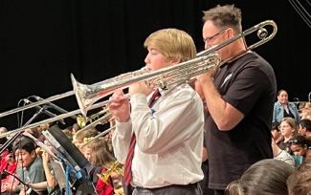
Strum, Strike and Blow held at the Horncastle Arena on Wednesday 3rd September. This was a fun-filled 90 minute concert involving over 2000 students from other schools in Christchurch. This year we took 75 students – a senior marimba/xylophone group, a big ukulele group (year 5 – 10 students) and a recorder group (Year 3 – 10). Mrs Carter takes the recorder group and all are welcome. The highlight this year was all our incredible soloists, involved in nearly every song! Yiling and Kimberly on recorders of various sizes, Sam on trombone, Saskia and Anna, singing with Voices Co, Lucinda on xylophone.

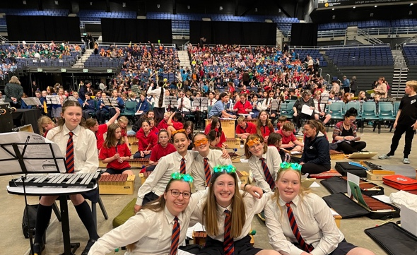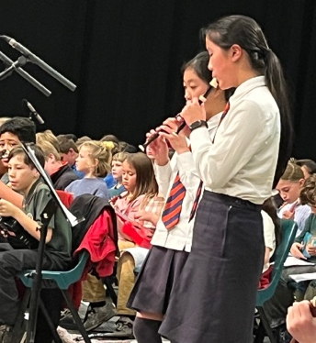

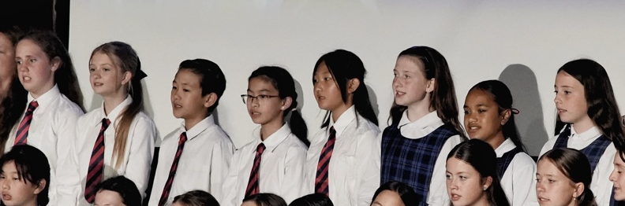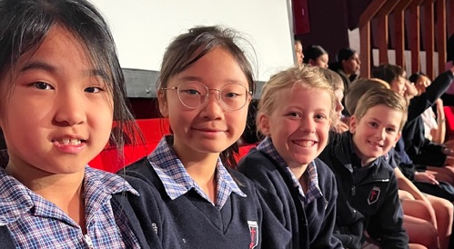

The Lions Christchurch Schools’ Music Festival (November 2 - 5) is an annual school choir event and this year more than 90 schools were participating. It was held in the Christchurch Town Hall for 4 nights. The performance for the Emmanuel Choir was on Wednesday 3 of November. We took 20 of our students who performed with enthusiasm and professionalism.
This year we had a record number of students involved in the Representative Groups.
Yiling Jiang – Bassoon: Concert Band
Kimberly Cheng – Lead Flute: Concert Band
Elle Ringland – Clarinet: Concert Band
Minah Yoon – Violin: Orchestra
Michelle Ou – Viola: Orchestra
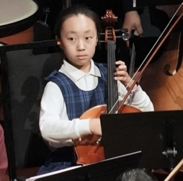
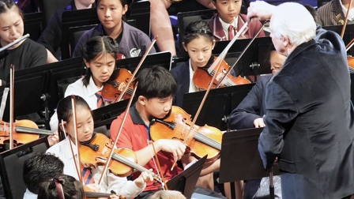
Seanna Yoon –Junior Choir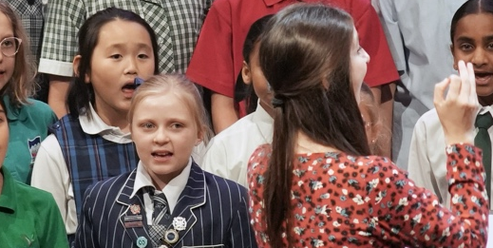

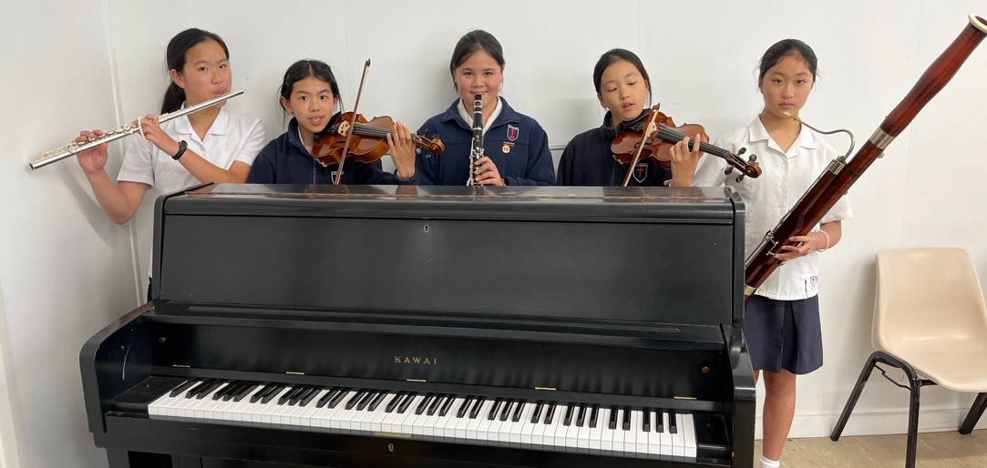

Christian Schools Tour: This year we took our Orchestra, our Senior Choir and some of our Junior Choir to Aidanfield Christian School and Middleton Grange to perform to their Primary classes. This is always an enjoyable day out - the highlight for me was seeing the joy on our Junior student’s faces during our lunch break when our Senior students chose to sit with them in little circle groups, inclusively chatting with them! It really highlighted our unique students and the lovely culture that music fosters!
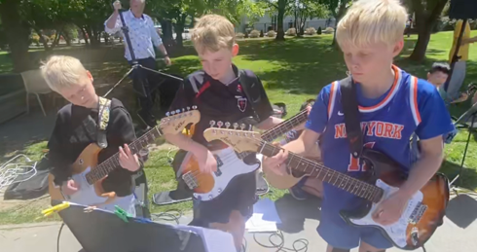
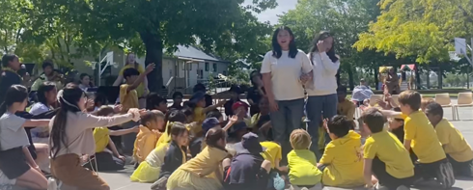
House Competition : Each year various House Competition are run; one of these is either a ‘Sing Off’ competition or a ‘Dance Off’ – this year our students sang and danced to Forrest Frank’s ‘ Your Way’s Better’. The artistic ideas and fantastic performances by each house, (involving every student at Emmanuel) in the fiercely contested battle was brilliant!
And…. It was accompanied by our very own worship band – no backing tracks for our fantastic students!!

Emmanuel’s Got Talent Competition
Organised by our fantastic Head student Lily, and our Arts and Culture Leaders, Lucinda and Cassia; we were entertained for a week with students competing in Dance, Music and ‘Other’ categories.
- Zeph took out the Overall Soloist prize with his exceptional talent on bass guitar – fingers flying so fast they were a blur.
- Saskia, Abby M and Esther – Group Singing prize with an acapella version of ‘Lost Boys.’
- Overall Champions were our fabulously talented string players with ‘Rosin Eating Zombies!’
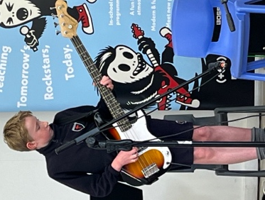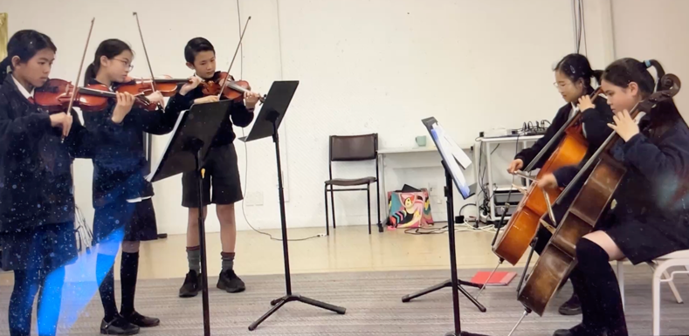
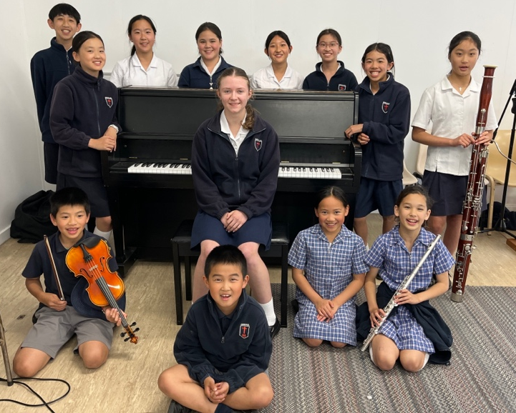
Music Exam Results for 2025
Lucinda (Yr 10) Grade 8 Piano with Merit and Grade 8 Cello with Merit
John (Yr 9) Grade 7 Piano with Distinction
Sam (Yr 9) Grade 5 Trombone with Distinction
Kimberly (Yr 8) Grade 7 Flute, Grade 5 Theory
Candance (Yr 8) Grade 1 Piano with Distinction
Belinda (Yr 7) Grade 5 Theory with Dist. Grade 6 piano
Michelle (Yr 7) Grade 5 violin with Distinction and CSM Scholarship Recipient for 2026
Noah (Yr 7) Grade 4 Piano
Elias (Yr 6) Grade 1 Piano with Distinction
Cody (Yr 5) Grade 2 Piano
Ella (Yr 5) Grade 3 Piano with Distinction
Onyu (Yr 5) Grade 2 Piano with Distinction
Bethany (Yr 4) Grade 4 Piano with Distinction
Samantha (Yr 4) Grade 3 Flute
Jeremy (Yr 4) Grade 1 Piano
Mason (Yr 4) Grade 2 Violin with Distinction

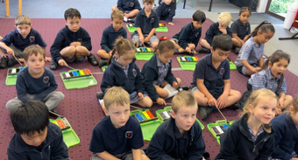
Classroom Music
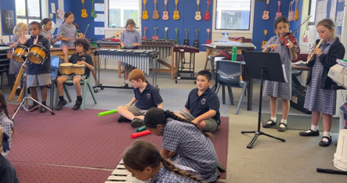
At Emmanuel starting in Harakeke, your child will learn the basic elements of Music. Over the years they will learn Recorder, Ukulele, Xylophone, Keyboard (senior option) Bucket Drumming, Cup Rhythms, Singing and Composition using computer programmes. They will be involved in end of Term Performances, Easter and Christmas Services and Productions – gaining valuable skills in performing!
Please encourage your child to be involved in the Music Programme at Emmanuel! I have spoken to various adults over the years who wished that they had been involved in Music when they were younger and couldn’t due to financial constraints, lack of opportunity or commitment. There are many opportunities that your child can join for free at Emmanuel which will give them an experience they will remember all their lives!
Assembly Performances
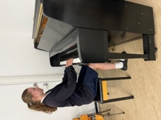
On Friday in the Junior Assembly, (Tuesday for Senior Assembly) students who are learning an instrument are encouraged to perform in front of their peers. We have had some outstanding performances this year and while this is brilliant training for the performer it is also trains the audience in polite etiquette - sitting quietly and listening to the performance. For those who are too scared to perform in front of such a large crowd, opportunities are given for students to perform in front of their class. Later in the year classes will also perform in Assembly items that we have been working on in class. Parents are always most welcome to attend our Assemblies!
Extracurricular Groups
- Senior Choir – Tuesday 8.15 -8.45 (extra practice Friday afterschool when nec.) all welcome
- Senior Acapella Group (Year 6 – 10) Term 1 Monday lunchtime (auditioned)
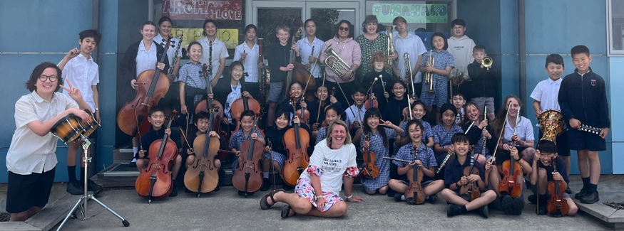
- Junior Choir (Year 1 – 6) Term 1 and Term 4: time to be determined, all welcome
- School Orchestra –– all students who have been learning for a year or more are encouraged to join. Tuesday 2.50 – 3.30 (Aiming to compete in 2026 in the Aurora Festival)
- Worship Band – Tuesday lunchtime: combined Junior and Senior band, Friday 8.30: Junior Assembly worship band. (Aiming to enter a band into the Band quest Competition 2026)
- Ukulele Group – Term 2 working toward the Strum, Strike and Blow Concert - lunchtime practice
- Marimba/Xylophone Group – Term 2 lunchtime (Year 7 – 10 students)
- Recorder Club –Term 2 Monday lunch (Year 3 – 10), Extension group – Wednesday before school
- Festival Choir – Term 3 Year 5 – Year 8, 1 hr per week
- Grade 5 Theory class – 1 hour after school for 10 weeks – revision for grade 5 ABRSM ($10 per week/student)
- Boom Whacker club – starting 2026 for one term, lunchtime practice

Itinerant Teachers
We are fortunate at Emmanuel to have some highly skilled Itinerant Music teachers and the programme is thriving! Please contact Louise Morrison at the school office if you are interested in having your child enrolled in any of the following Music lessons:
- Anne Robinson and her team from the Christchurch School of Music oversees the string programme and offers both violin and cello lessons. Many of our students are also playing in the Orchestras at CSM – a huge opportunity! There are spaces available for a few more students to be involved in the string programme, lessons are in school time on Wednesday. Download: Outreach Strings flyer 2026.pdf

- Maree Par is our flute, clarinet and saxophone teacher. She also comes to us with years of experience and her students are flourishing! She also has spaces for more students, lessons are on Tuesday.

- Haram Lee teaches piano and is in school on Thursday and part of Friday. Haram is extremely patient and is an excellent teacher, I cannot recommend her highly enough, she is outstanding! Her students are achieving very high results in their exams.

- Adrian Dalton is our trumpet and trombone teacher, he is head of the Norwest Brass Band and students learning from Adrian also have the wonderful opportunity of joining his Brass Band! Spaces are available for more students, lessons are on Tuesday morning.

- Daniel Hitchens is the creator of the Monster Music programme and he and his team offer drums, guitar and ukulele lessons. Students in this programme are often involved in performing in many of the amazing concerts that Daniel and his team organise! Lessons are on Monday and Thursday.

Any Music Inquiries: Please feel free to come in and see me in the Music Classroom if you have any questions about the school Music Programme or send me an email: naomi@emmanuelchristian.school.nz
Naomi Langford – Emmanuel Christian School Music Specialist Teacher
(B. Music (Performance), Grad Dip.Teaching L.T.C.L, A.T.C.L)

