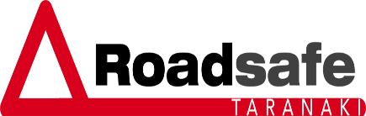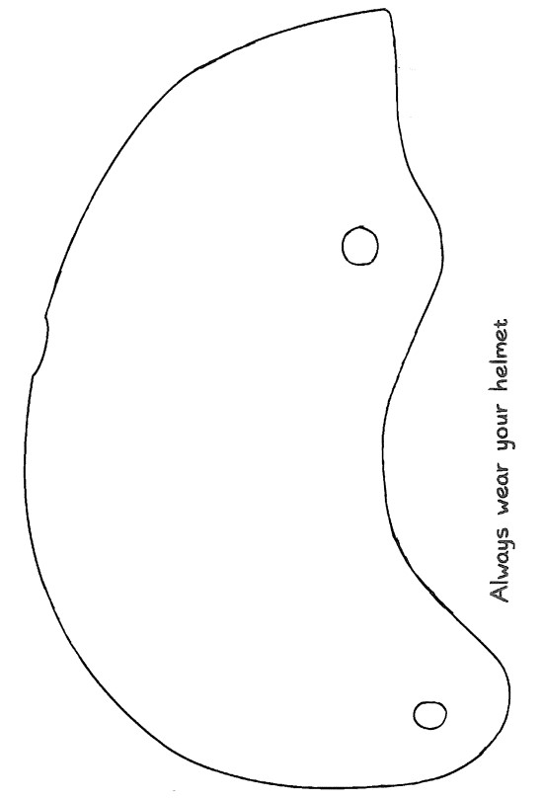
Helmet Competition 2026

Rules/Eligibility:

1.

Only one entry per person.

2.

Roadsafe Taranaki will supply helmet to be
painted.

3.

Three categories:

a.

Year 0
-
)
(3 prizes
3

b.

Year 4
-
6
)
(3 prizes

c.

Year 7
-
)
(3 prizes
8

4.

Entries Close

31sst
July 2026

and are
to be handed in to
your

school office.

Winners
will be
notified
in
Term 3 of 2026.

5.

Judge
s decision is final.

6.

Roadsafe Taranaki will
take a

photo of each
winner and their painted helmet:

a.

We will use photos on social media
pages.

b.

If a parent does not agree to this,
please inform us when we notify
about win.

Mau tonu tō potae mārō

|

Name:

__________________________________________

Year 0
-
/
3
4
-
6
/
7
-
8

Circle the year group that applies

Sc
hool:

__________________________________________

Contact Phone:

__________________________

The painted helmet will be reproduced as close as pos
sible to the original design

however
,

some elements may need to be altered by the artist to suit the sha
pe of the helmet and the paint medium used.

